Windchill CPS 13.0.2.5 Installation - RH1
Schindler CRD Applications

Exported on 2025-08-19 05:10:52

Table of Contents

1 3
2 Prerequisites: 4
3 CPS Installation Procedure: 5

- Prerequisites:
- CPS Installation Procedure:

Prerequisites:
- Need Admin access on Windchill Application server.
- OOTB Windchill should be already installed and in working condition.

CPS Installation Procedure:
- Stop Windchill and Apache.
- Make sure Windchill DS is running.
- Uninstall Windchill, Apache and DS as services if they were added as Windows services.
- Download and extract CPS installable.
- Launch Command Prompt as Administrator and stage to PSI directory of CPS as shown below and execute setup.vbs
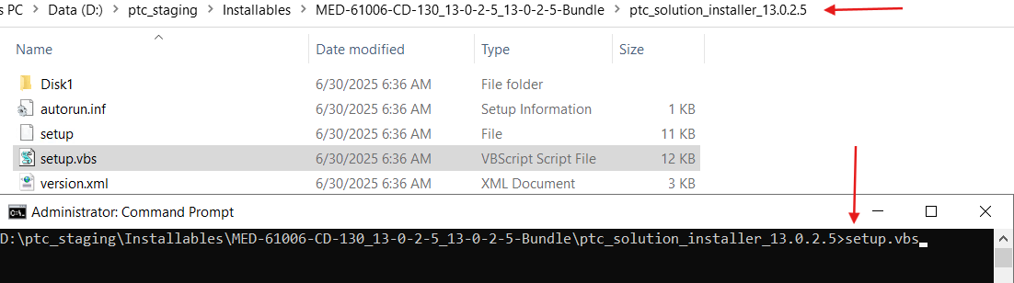

6. Uncheck the box and click on Open.
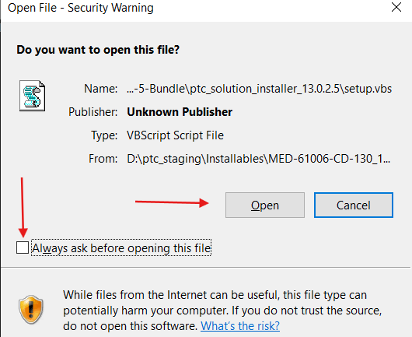
7. Click on Ok.
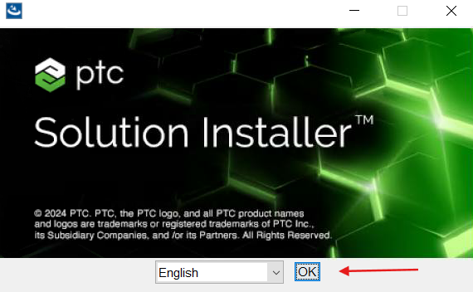

8. Click on Next.
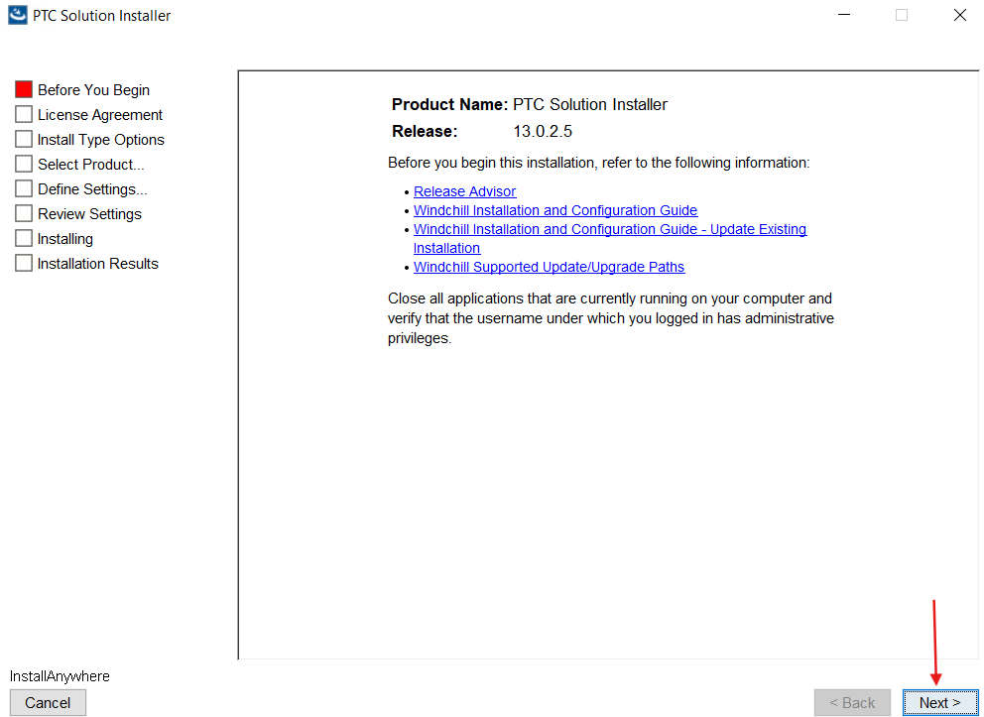

9. Accept the agreement and click on Next.
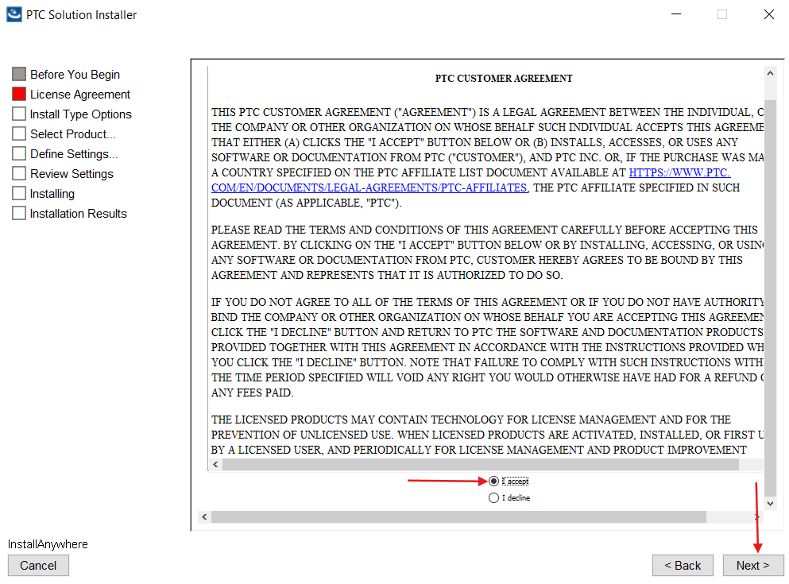

10. Select "I have read the above statement" and click on Next.
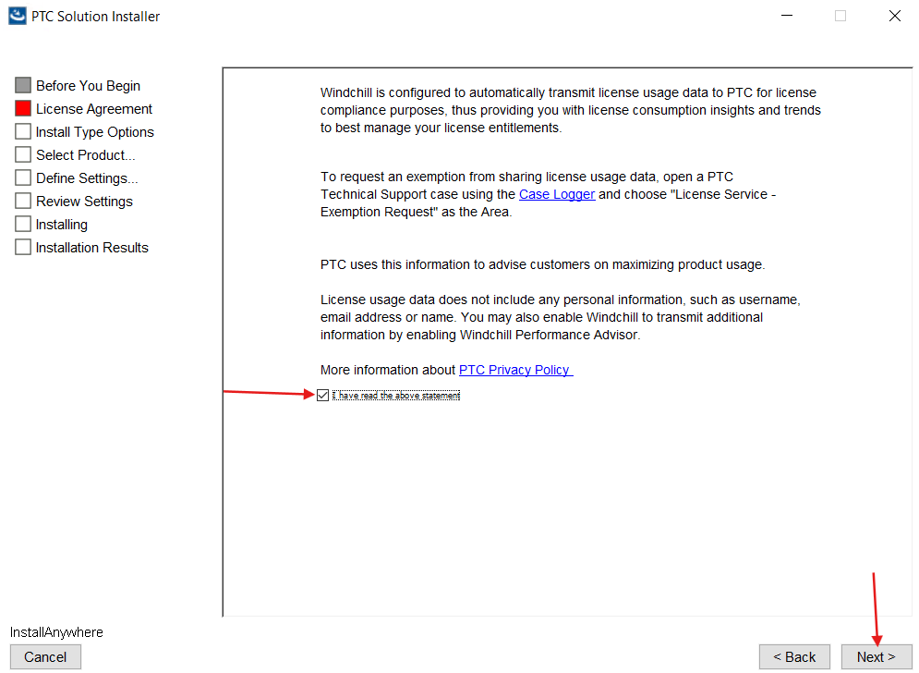

11. Select "Update Existing Installation" and click Next.
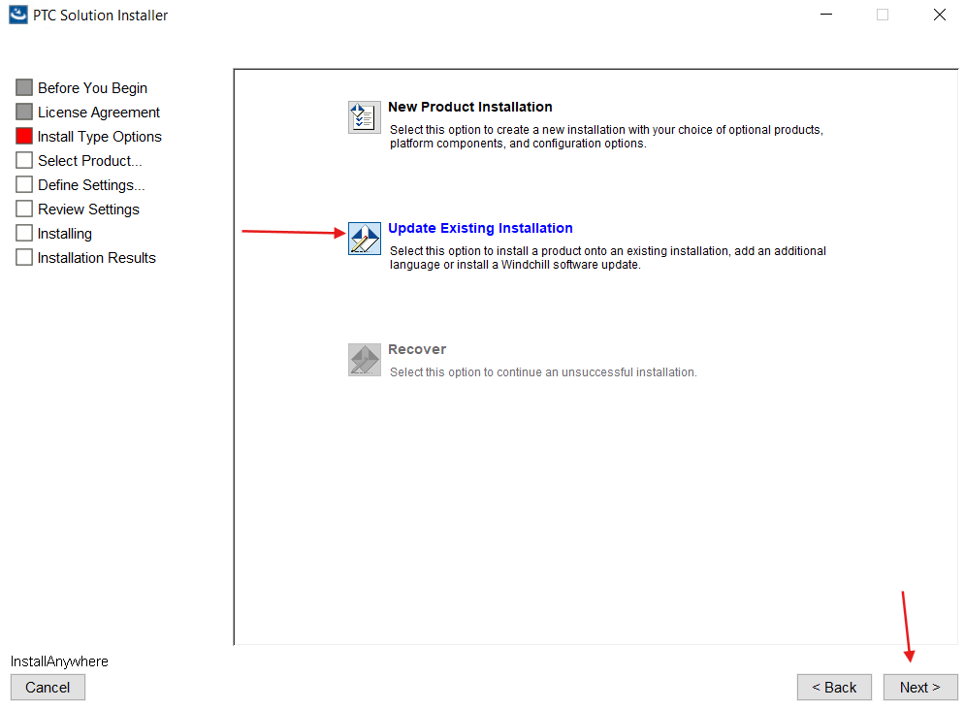

12. Select the Installation to update and click on Next.
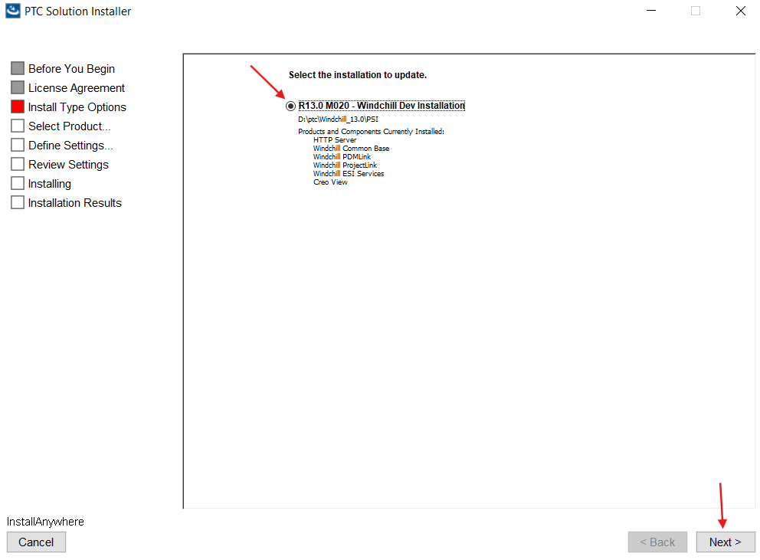

13. Select "Install Critical Patch Set" and click Next.
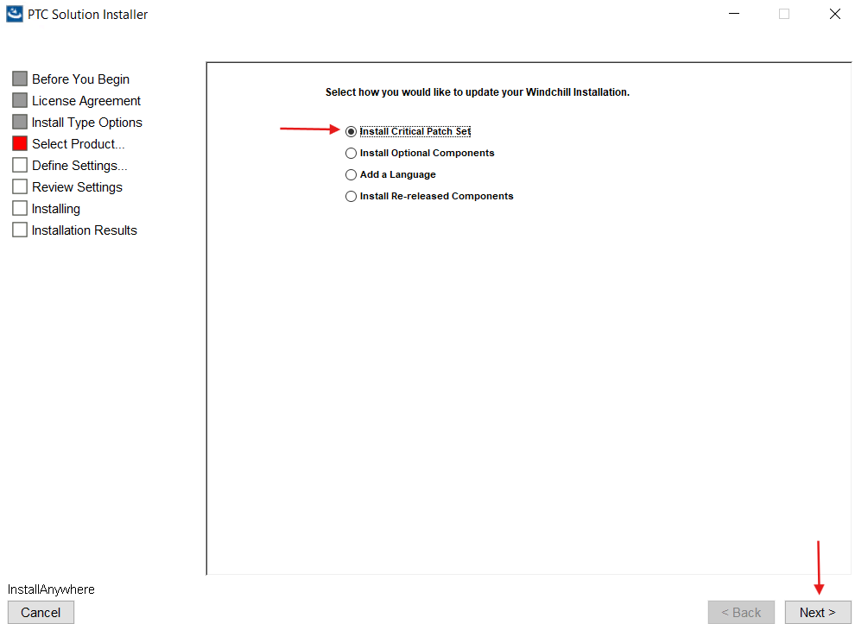

14. Click on Yes.
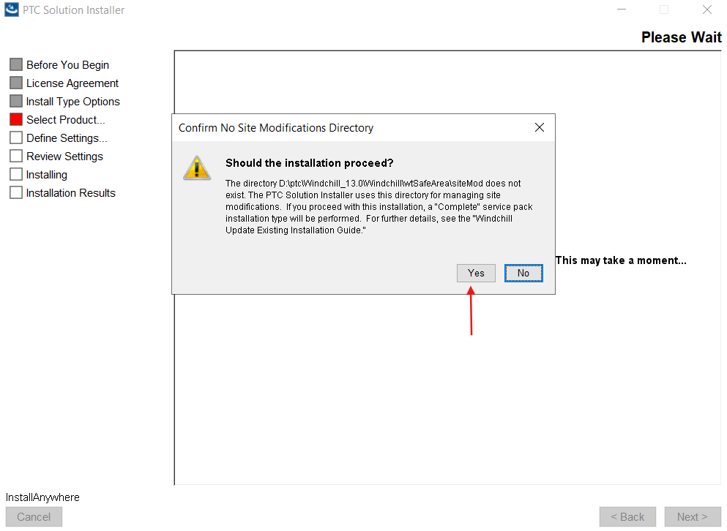

15. Click on Next.
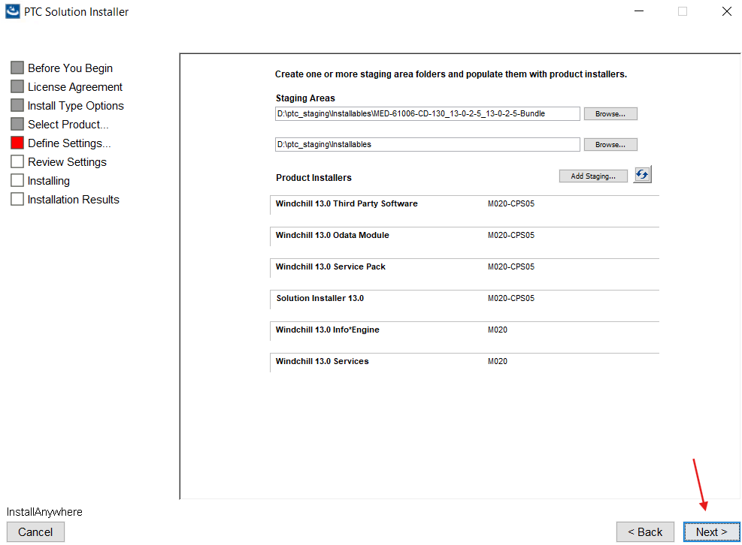

16. Click on Next.
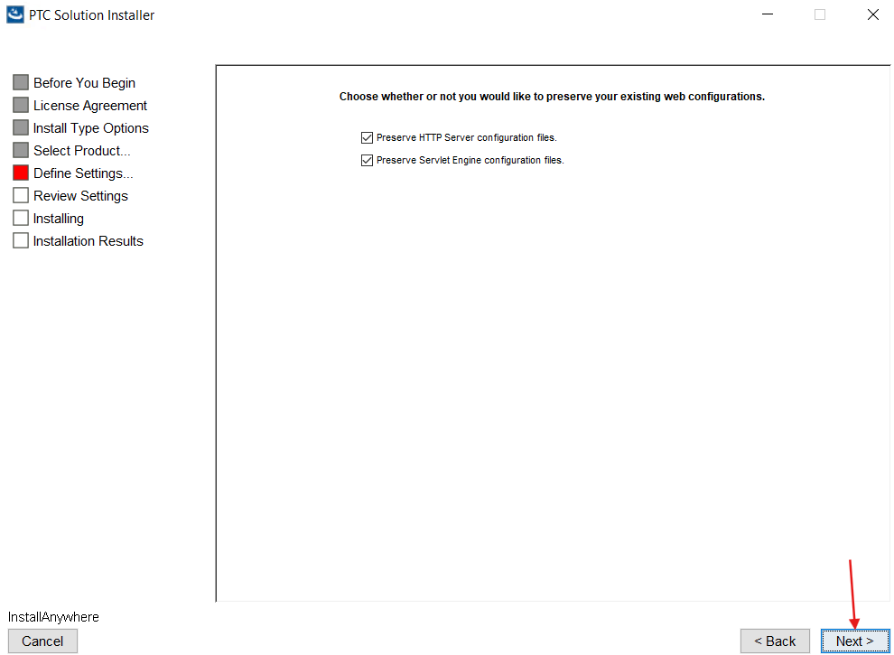

17. Verify Installation details and click on Install.
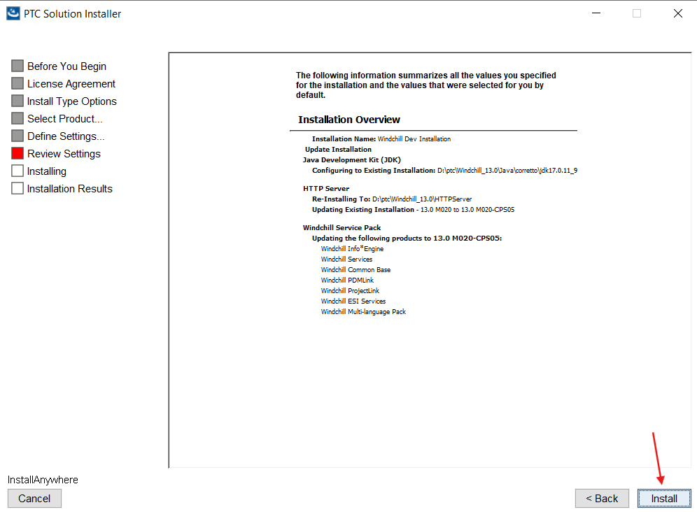

18. Click on Done.
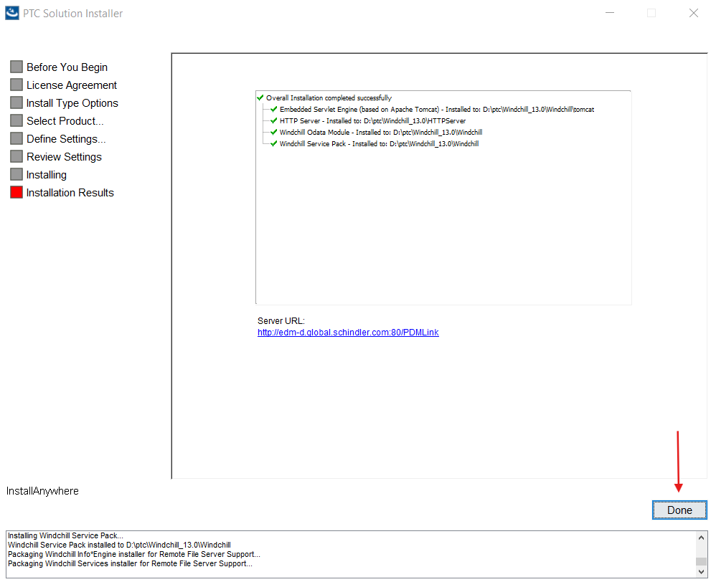

19. Clean cache and start Windchill.

